Architecture Design

Data Visualization of Bird Strikes between 2000 – 2011

By

Ankit Anshu

**Contents**

1. Introduction........................................................................................................................ 04

1.1 What is Architecture Design Document? .......................................................... 04

1.2 Scope ..................................................................................................................... 04

2. Architecture ....................................................................................................................... 05

2.1 Tableau Architecture ........................................................................................... 05

2.2 Tableau Server Architecture................................................................................ 05

2.3 Gateway/Load Balancer .................................................................................... 06

2.4 Application Server ............................................................................................... 06

2.5 VIZQL Server ......................................................................................................... 07

2.6 Data Engine ........................................................................................................... 07

2.7 Backgrounder ....................................................................................................... 07

2.8 Data Server ........................................................................................................... 07

2.9 Tableau Communication Flow ............................................................................ 07

3. Deployment ........................................................................................................................08

3.1 Deployment Options in Tableau .........................................................................09

3.2 Single Node Architecture .................................................................................... 10

3.3 Three Node Architecture .....................................................................................11

3.4 Five Node Architecture ........................................................................................12

**1. Introduction**

Over the past few years there has been increasing attention focused on the potential risks’ wildlife pose in aviation. While the civil and military communities recognize the threat of wildlife strikes, incidents such as the forced emergency landing of US Airways Flight 1549 in the Hudson River in 2009 have brought it into the public eye making us more aware of the potential dangers. According to the FAA the threat of wildlife strikes is increasing. The number of annual strikes reported has increased from 1,793 in 1990 to 9,474 in 2009. The Federal Aviation Administration (FAA) has had ongoing efforts and is involved in programs to improve the situation. One of its efforts includes developing a voluntary reporting system to collect wildlife strike related data. This data is available to the public in the FAA Wildlife Strike Database. e this report offered multiple tables of data and a few graphs; it is quite lacking in visualizations of the data contained in the FAA Wildlife Strike Database. In our paper we explore the data in the FAA Wildlife Strike Database and demonstrate how various information visualizations can be applied to the data to reveal patterns and facts which could help in understanding the data and in creating mitigation plans to avoid these safety risks. For instance, can the data reveal to us whether or not airports are doing all they can to minimize wildlife strikes? Can the use of visualizations reveal any problems that the FAA’s analysis has not already revealed?

**2. Architecture**

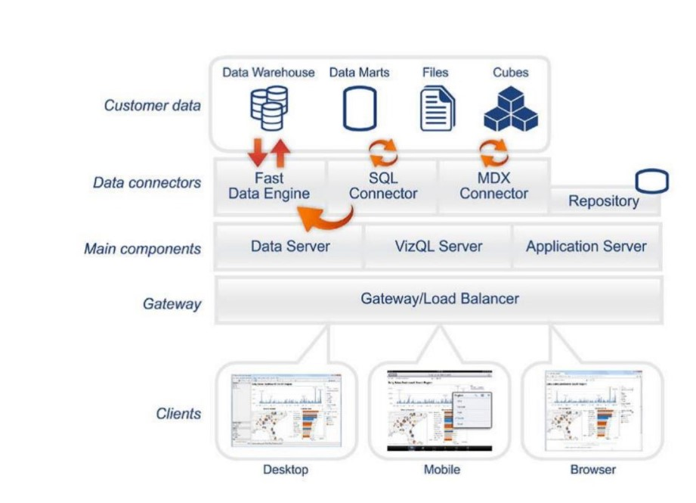

**Tableau Server Architecture**

Tableau has a highly scalable, n-tier client-server architecture that serves mobile clients, web clients and desktop-installed software. Tableau Server architecture supports fast and flexible deployments.

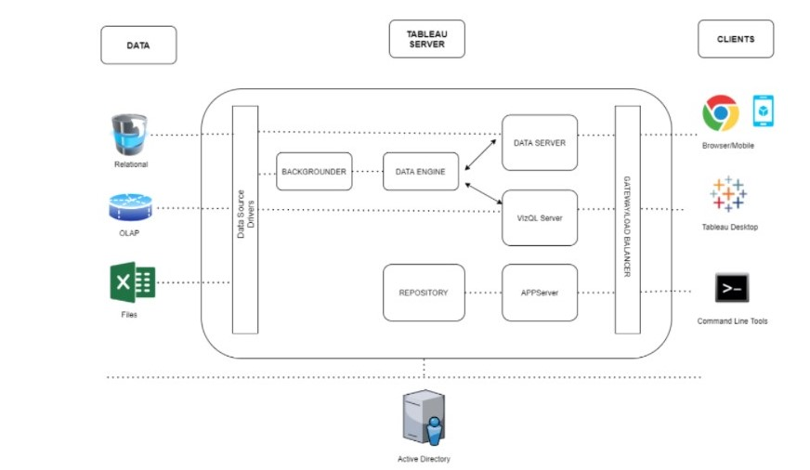

Tableau Server is internally managed by the multiple server processes.

1. Gateway/Load Balancer

It acts as an Entry gate to the Tableau Server and also balances the load to the Server if multiple Processes are configured.

2) Application Server: -

Application Server processes (wgserver.exe) handle browsing and permissions for the Tableau Server web and mobile interfaces. When a user opens a view in a client device, that user starts a session on Tableau Server. This means that an Application Server thread starts and checks the permissions for that user and that view.

3) Repository: -

Tableau Server Repository is a PostgreSQL database that stores server data. This data includes information about Tableau Server users, groups and group assignments, permissions, projects, data sources, and extract metadata and refresh information.

4) VIZQL Server: -

Once a view is opened, the client sends a request to the VizQL process (vizqlserver.exe). The VizQL process then sends queries directly to the data source, returning a result set that is rendered as images and presented to the user. Each VizQL Server has its own cache that can be shared across multiple users

5) Data Engine: -

It Stores data extracts and answers queries.

6) Backgrounder: -

The backgrounder Executes server tasks which includes refreshes scheduled extracts, tasks

initiated from tab cmd and manages other background tasks.

7) Data Server: -

Data Server Manages connections to Tableau Server data sources. It also maintains metadata from Tableau Desktop, such as calculations, definitions, and groups.

8) Tableau Communication Flow

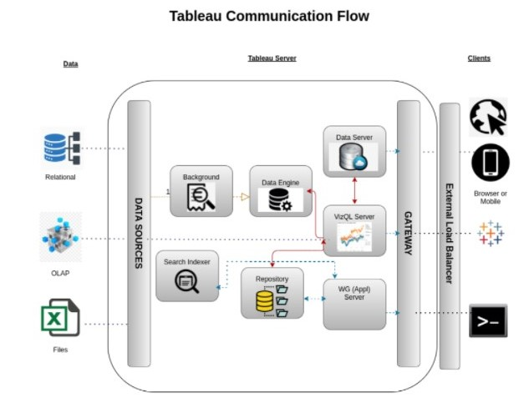

**3. Deployment Description**

Tableau’s analytics platform offers three different deployment options depending on your environment and needs.

